# Workshop Personas - Mobile Interaction Design

**Main goal of this workshop:**

Gain insight in the importance of empathy as a designer. On size does not fit all.

Designers need to focus on their primairy user and one technique IXD uses is the Persona.

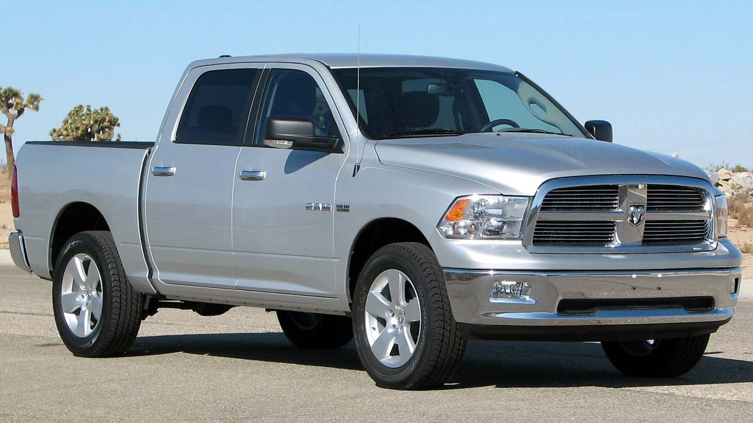

*Dodge Ram van*

**1. Describe this customer - what characteristics define this user?**

*use text, images from Google or make a sketch - 10 minutes*

**2. Discussion**

What are the common grounds we found? Can we translate this into software?

*frontal presentation/discussion.*

**Know thy users**

Given are:

* 10 types of users: Business Woman, Stay-at-home dad, Grandma Johnson, Music student (classical), Metal Guitarist, Television Show host, Enterprising entrepeneur, Interaction Designer, Lecturer at Fontys, Refugee.
* 10 types of environments: Car, Train station, Hotel room, In the office, At home, On the train, In the street, In the pub, Librairy, In school.
* 1 Application: Spotify

**3. You will be assigned 1 specific user**

*Make a Persona of this user (first, do some desk research about personas)*

**4. You will be given 1 specific environment**

(Now you have a persona, an environment and an application: Spotify.)

*Redefine the requirements/features and/or user interface of Spotify to best serve this user in this specific environment. - 60 minutes*

**5. Hand in/Presentation/Discussion** (a selection of students presents their findings)

*Hand in your documents and prepare to present your findings*